MATHEMATICS SPECIALIST

MAWA Semester 1 (Unit 3) Examination 2017

Calculator-free

Marking Key

© MAWA, 2017
Licence Agreement
This examination is Copyright but may be freely used within the school that purchases this licence.
- The items that are contained in this examination are to be used solely in the school for which they are purchased.
- They are not to be shared in any manner with a school which has not purchased their own licence.
- The items and the solutions/marking keys are to be kept confidentially and not copied or made available to anyone who is not a teacher at the school. Teachers may give feedback to students in the form of showing them how the work is marked but students are not to retain a copy of the paper or marking guide until the agreed release date stipulated in the purchasing agreement/licence.

The release date for this exam and marking scheme is
- the end of week 8 of term 2, 2017

Section One: Calculator-free (52 Marks)

Question 1(a)
Solution
, and
(i)
(ii)
(iii)
Marking key/mathematical behaviours | Marks
(i)  - Determines  (ii)  - Determines and multiplies  - Expresses the result in the form  (iii)  - Indicates the need to multiply by  - Multiplies this correctly  - Re-arranges in the form | 1  1  1  1  1  1

Question 1(a)
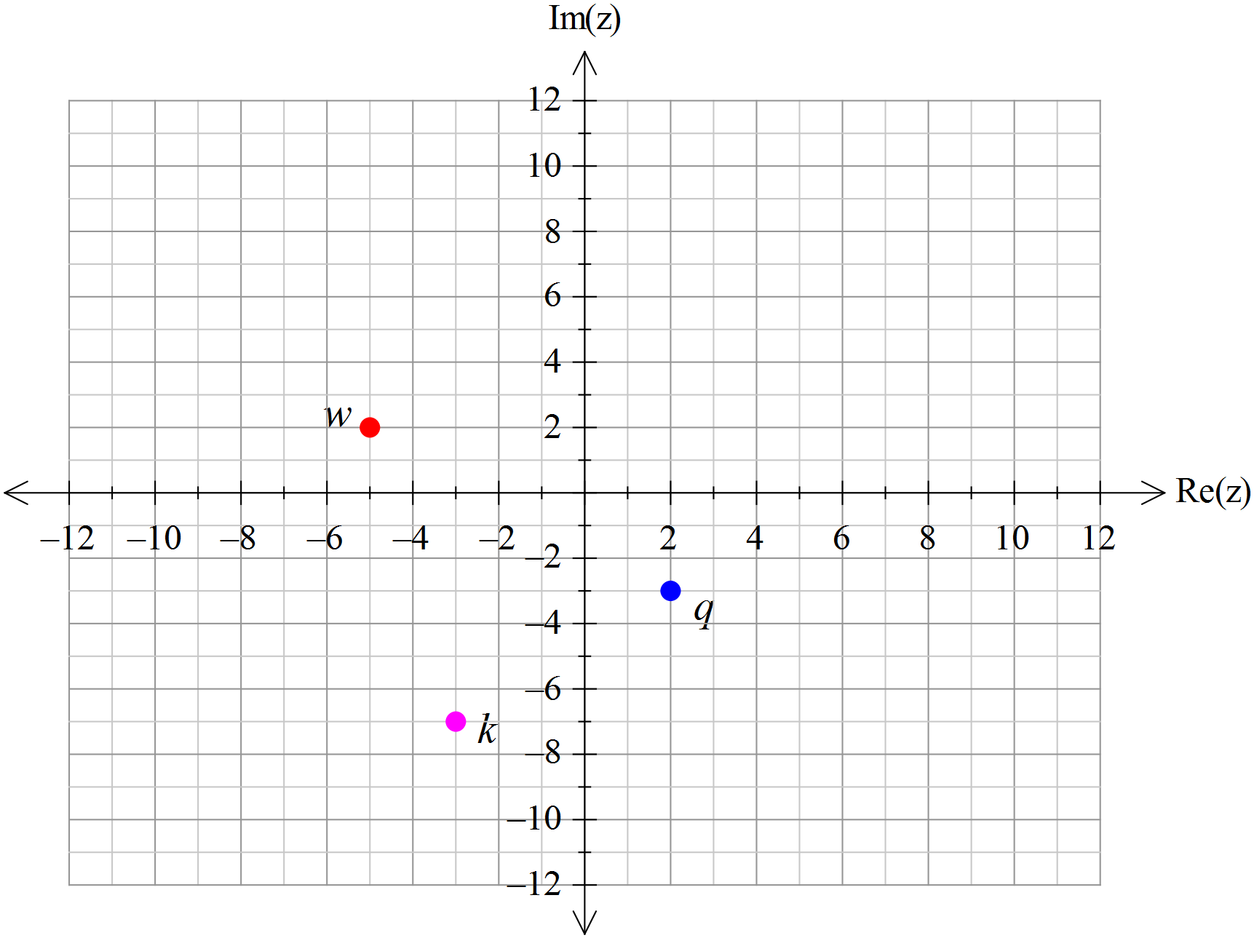Solution

Marking key/mathematical behaviours | Marks
- Correctly plots  - Calculates  - Correctly plots | 1  1  1

Question 2(a)
Solution
Marking key/mathematical behaviours | Marks
- substitutes the correct exact values into cis  - simplifies correctly | 1  1

Question 2(b)
Solution
Marking key/mathematical behaviours | Marks
- applies de Moivre’s theorem  - substitutes exact values  - simplifies | 1  1  1

Question 2(c)
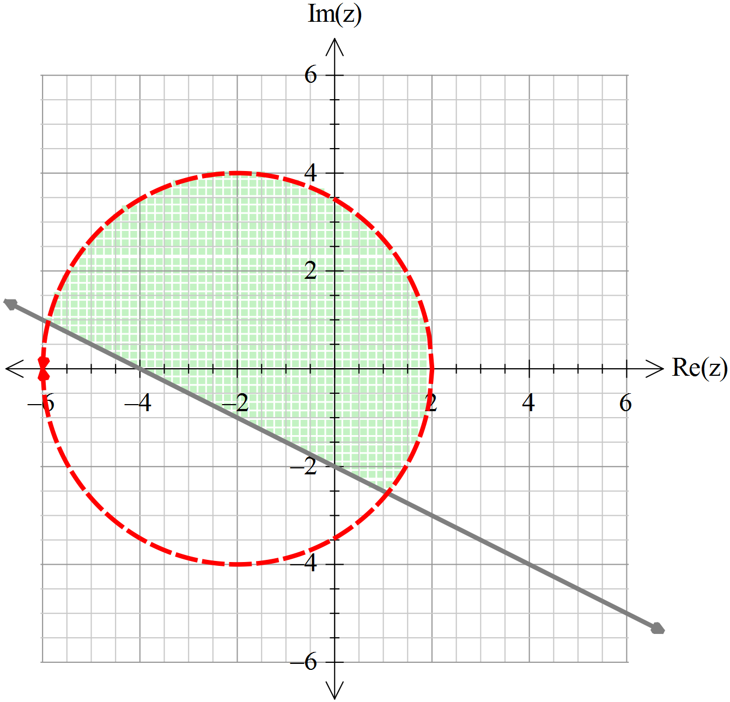Solution

and

Marking key/mathematical behaviours | Marks
- Correctly states inequation for half plane above the line  - Correctly states the inequality of the circular region  - Indicates that it is the intersection of the two regions (ie uses “and”)  - Indicates the boundaries correctly by using the appropriate symbol within each inequation | 1  1  1  1

Question 3(a)
Solution
Marking key/mathematical behaviours | Marks
- determines expression  - states domain  - states range | 1  1  1

Question 3(b)
Solution
Marking key/mathematical behaviours | Marks
- determines expression  - states domain  - states range | 1  1  1

Question 3(c)
Solution
Marking key/mathematical behaviours | Marks
- rewrites function in turning point form  - states range | 1  1

Question 3(d)
Solution

Restricted domain:

Marking key/mathematical behaviours | Marks
- restricts domain correctly  - swaps and  - solves for  - determines the correct inverse rule | 1  1  1  1
Question 4
Solution

are asymptotes:

Marking key/mathematical behaviours | Marks
- states values of c and d  - states value of b  - states value of a | 1  1  1

Question 5(a)
Solution

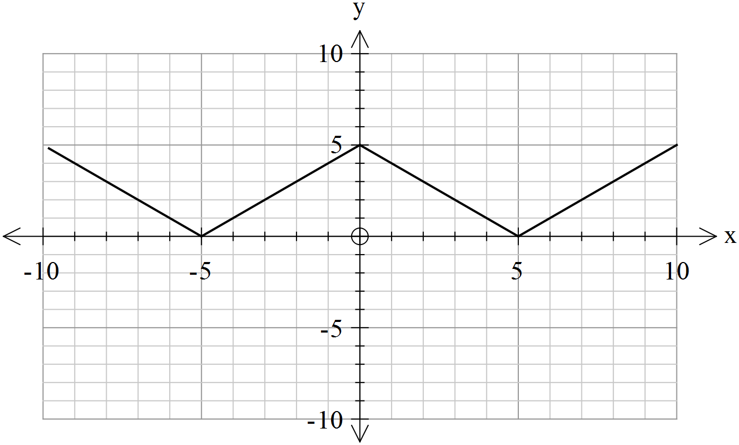
Marking key/mathematical behaviours | Marks
- sketches for  - sketches for | 1  1

Question 5(b)
Solution


Marking key/mathematical behaviours | Marks
- sketches for  - sketches for | 1  1

Question 5(c)
Solution

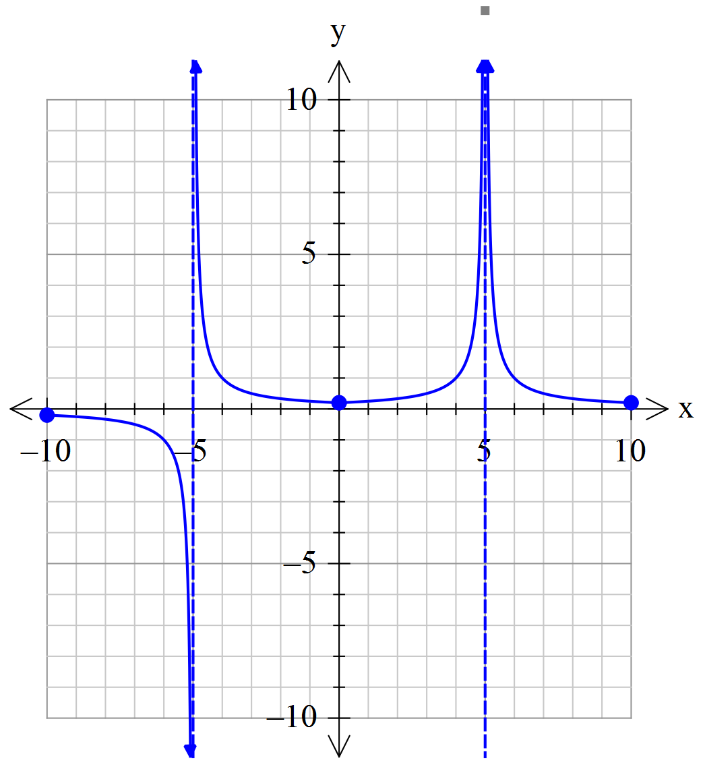

Marking key/mathematical behaviours | Marks
- shows two asymptotes  - shows intercept (=0.2)  - sketches correctly (shape and accuracy) | 1  1  1+1

Question 6(a)
Solution

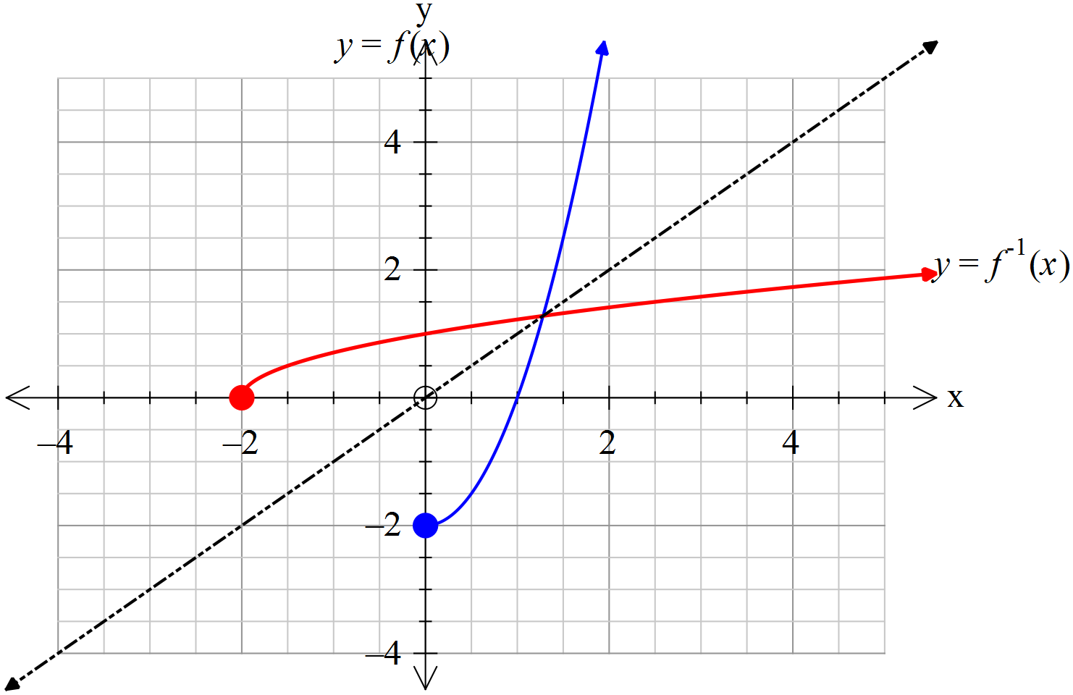
Marking key/mathematical behaviours | Marks
- sketch of inverse appears as a reflection in the line  - shows correct end-point of (-2,0) and indicates continuation past  - sketch has a reasonably accurate shape (ie. crosses at roughly the correct spot) | 1  1  1

Question 6(b)
Solution

EITHER, uses point of intersection from graph,

OR, solves algebraically,
Marking key/mathematical behaviours | Marks
EITHER OR  - uses point of intersection establishes equation to solve  - states value near 1.3 states value | 1  1

Question 7(a)
Solution
$$\begin{matrix}x+3y-2z & = & 3 \\ 4x+14y-3z & = & 19 \\ 3x+12y+2z & = & 21\end{matrix} ⟺ \begin{matrix}x+3y-2z & = & 3 \\ 2y+5z & = & 7 \\ 3y+8z & = & 12\end{matrix} ⟺ \begin{matrix}x+3y-2z & = & 3 \\ 2y+5z & = & 7 \\ z & = & 3\end{matrix}$$

So $z=3$, and back-substitution gives $y=-4$ and $x=21.$

Marking key/mathematical behaviours | Marks
- systematically eliminates variables  - solves for  - solves for and | 1  1  1

Question 7(b)
Solution
$$\begin{matrix}x+3y-2z & = & 3 \\ 4x+14y-3z & = & 19 \\ 3x+12y+az & = & b\end{matrix} ⟺ \begin{matrix}x+3y-2z & = & 3 \\ 2y+5z & = & 7 \\ 3y+\left(a+6\right)z & = & b-9\end{matrix}$$

$$⟺ \begin{matrix}x+3y-2z & = & 3 \\ 2y+5z & = & 7 \\ \left(2a-3\right)z & = & 2b-39\end{matrix}$$

Infinitely many solutions when last equation reduces to $0z=0$,
i.e. $a=1.5$ and $b=19.5$
Marking key/mathematical behaviours | Marks
- systematically eliminates variables  - uses the condition for infinitely many solutions  - solves for and | 1  1  1

